66

Activity Ideas for Creating a Warm and Welcoming Environment
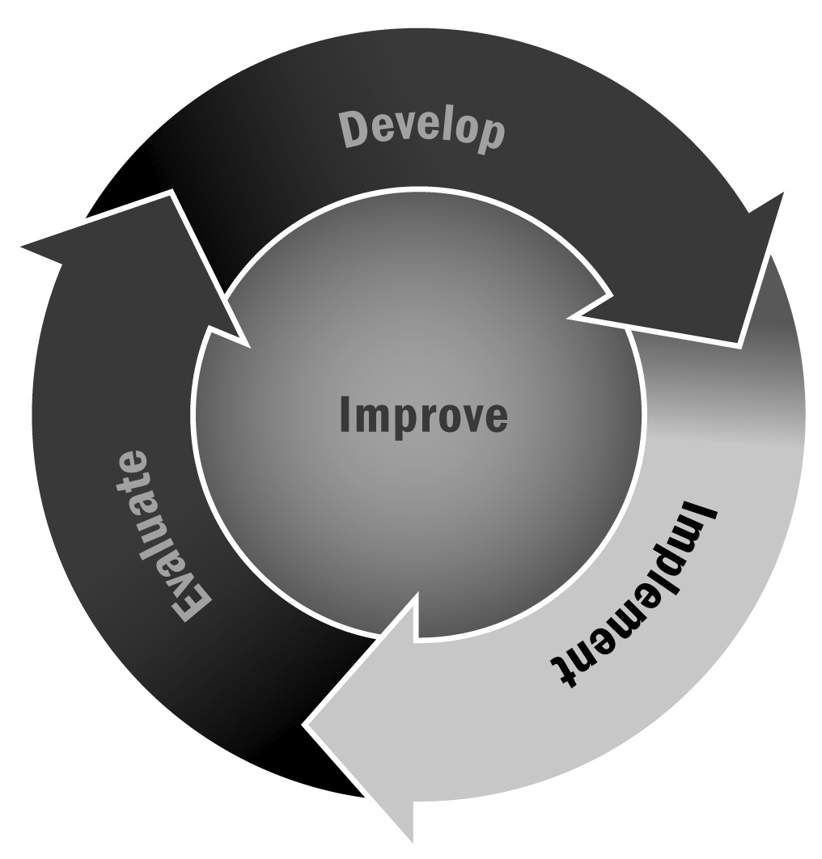
In Chapter 4, you learned that having a warm and welcoming environment is a building block for programs. In fact, research shows that youth having a sense of belonging and security in programs has been linked with improved academic performance, increased levels of motivation, a strong willingness to learn, and decreased behavior problems (Faircloth & Hamm, 2005; Kauh, 2011; Marzano & Marzano, 2003). That said, the environment of the program is influenced greatly by the interactions among people within the program, so implementing activities that create a warm and welcoming environment will be critical to the success of your program.
Directions: Use (or adapt) these activity ideas during your program sessions. The activities below are split into different activity types, with different focus areas, and suggestions for using them during the session.
Remember:
- We all need to feel like we belong, and young people are no different. That’s why you’re doing this, right? But it takes time to establish trust and develop bonds both among youth in your program and between the staff and youth. Offer a variety of activities that give youth an opportunity to get to know each other in different ways and see what works best.
- Pay close attention to grouping. Using grouping strategies (e.g., counting off, birthdays, straws) allows for youth to expand their peer group and avoid unwanted exclusion or cliques. Make sure to alternate grouping strategies so all youth have a chance to work, grow, and develop positive relationships.
- Always offer youth the option to pass—these activities should be a fun and positive experience. Do take note if certain youth always pass or if certain activity ideas don’t go over as well as others, and let that inform how you do things the next time.
- Getting to know other people and sharing personal information can sometimes be intimidating. Start out with easy questions and activities that allow youth to maintain personal space and increase the level of intimacy and sharing as the year progresses and everyone gets to know each other better.
- Give youth freedom to make choices. Maybe this means letting them choose whether this is done as an individual sharing activity or as a pair-share or in small or large groups. You might have them choose their own partners or groups. Do what is most comfortable for youth in your program.

Group Activities
Practices | Activities | Example | Ideas for Your Program
Greetings | Alphabetical | Youth pick random letters and find peers with a name that starts with the letter chosen.
 | Compliments | Youth sit in a circle and take turns giving peers a compliment.
 | Nonverbal | Youth silently greet each other with handshakes, high fives, ankle taps, fist bumps, or other unique ways of silently saying hello.
Think and Tell | Getting to Know You | Have youth explain their favorites: color, food, sport, subject, animal.
 | Thinking Forward | Have youth describe their life goals or dreams.
 | Reflections | What is your favorite thing about yourself?
Teamwork | Relay Race | Have youth pick groups and work on a time challenge (groups should be randomized to avoid exclusion).
 | Mysteries | Divide youth into pairs or small groups to solve a mystery involving clues (groups should be randomized to avoid exclusion).
 | Silent Puzzles | Have youth get into a line by their birth month without talking.
Brain Breaks and Energizers | Smiles and High Fives | Have youth walk around the room and acknowledge each other with smiles and high fives.
 | Catching Questions | Each person writes down a question and throws his or her question to someone else to answer.
 | Remember What You Learned | Youth go around and share one thing they learned during the lesson or activity.
Responsibilities | Clean-Up Coordinator | Assign or encourage youth to select duties to coordinate clean-up time.
 | Timekeepers | Assign youth (or encourage them to volunteer for) duties to manage program activities.
 | Attendance | Assign youth duties to sign participants in and out.
Closing | Checkout | Have youth share one thing they enjoyed doing today and why.
 | “Props” | Youth share compliments with a peer on something they did during the program. This can be done in pairs or in a large group.

